Response to Reviewers **Schilling et al**

Thank you for the opportunity to respond to the reviews. This response letter is formatted to give each editor/reviewer comment (numbered) followed by a response to each comment in blue and quotes from the main text in *blue italics*.

**Reviewer 1:**

**Comment #1:** Zooplankton play important roles in marine ecosystem. The observation of biological oceanography is far behind the physical and chemical oceanography due to the limitation of the observing technique of biological variables. The authors presented the high resolution vertically resolved profiles of the zooplankton biomass and size structure across four transects over a continental shelf, and discussed the relationship between zooplankton and relevant physical processes, which provided important information on the zooplankton characteristics on the eastern continental shelf of Australia and insights of the zooplankton pattern over the continental shelf. However, the single cruise, the lack of the simultaneous chemical oceanographic observation, the lack of zooplankton taxa and statistical analysis make the mechanism more descriptive.

**Response:** We appreciate the reviewer highlighting the importance of our study in describing the zooplankton characteristics over the eastern continental shelf of Australia and acknowledge that our study is largely descriptive. This descriptive nature is due to the sampling design of 4 transects which may bias any statistical analyses due to autocorrelation. Rather than calculate spurious statistics we prefer to present the observed patterns. Remarkably, the cross-shelf patterns we observe seems to reflect other coasts around the world (Figure 8).

We have now incorporated more chemical oceanographic observations which we think provide more certainty in some of our findings and help to place the observations from our study in a broader seasonal context. The newly included chemical observations all provided in the supplementary material include cross shelf transects of Salinity, Nitrate, Silicate, Oxygen and Chlorophyll *a* all overlaid with temperature contours for comparison (Supplemental Figures 9, 10, 11, 12,13). Unfortunately, zooplankton samples were not able to be collected on this voyage for logistical reasons. We agree that taxonomic information would add further value, but the biomass, abundance and size-distribution information we present nonetheless provides important information about energy transfer within the planktonic ecosystem.

**Comment #2:** 1) Zooplankton biomass is highest inshore, which declines with increasing distance from shore and with increasing depth in the water column. This is true for most continental shelves or transects from the coast to the open ocean according to the published work. One purpose is to relate the observations to previous research to propose a general concept of zooplankton size-structure on continental shelves globally. The continental shelf is different globally, if there is a globally general pattern, does that mean that the influence of the western boundary current is not the key process affecting the zooplankton community structure? Maybe different inherent mechanisms can be classified based on different locations, not necessarily one general concept globally.

**Response:** The common fundamental process that unites all studies is the nutrient enrichment that occurs in all near-coastal waters, due to many different upwelling processes (coastal winds, reverse Ekman, or topographic effects) and estuarine processes and run-off from land. Therefore, western boundary currents do have a major influence on coastal enrichment, but are not the only cause. This drives the ubiquitous “green-ribbon” (Lucas et al. 2011) in chlorophyll-a observed along most coasts world-wide, and our study together with related work establishes a general pattern in zooplankton size and abundance. We have now made a point in the discussion of how the general patterns in zooplankton are likely due to coastal nutrient enrichment which can be caused by both western boundary current among other causes. The discussion now states:

*“These horizontal trends in the particulate (zooplankton) size-structure are consistent with the patterns in size-structure across other continental shelves and likely are an outcome of nutrient enrichment which tends to occur on continental shelves. This enrich can come from a variety of sources including cross-shelf flows and sporadic upwelling processes driven by ocean currents and coastal winds (Roughan and Middleton, 2002; Malan et al., 2020), estuarine process (Morris et al., 1995) or run-off from land (Correll et al., 1992).”*

We have also added some discussion about how the cross-shelf gradients (produced as discussed above) are a key component of the observed zooplankton dynamics:

*“Despite different regional dynamics, cross-shelf and vertical gradients in water-masses, here driven by the EAC and uplift, seem to be the dominant factor for the patterns observed at various locations worldwide.”*

**Comment #3:** 2) According to the previous research, the change of the vertical patterns of the zooplankton size related to the depth of the target area. For example, the zooplankton became larger with increasing depth (>100 m) in some areas. The depth of this research is about 100 meters or less, I think the authors should clarify that in the range of 0-100m, the size become smaller with the increasing depth.

**Response:** We have now clarified this point in the abstract, results and discussion. For example, the abstract now states:

*“Particulate (zooplankton) biomass was highest inshore, declining with increasing distance from shore and with increasing depth in the top 100m of the water column.”*

**Comment #4:** 3) The survey was conducted in one week. Considering that one purpose of this work is to find a general concept, are there any evidences that can prove that the seasonal change is not dramatic in this area?

**Response:** There are substantial seasonal changes in the strength of the East Australian Current (faster in spring and summer, Fig. 2), and therefore in the frequency of upwelling (strongest in spring, Rossi *et al* 2014). We selected spring when many commercial fish spawn, but as shown in Fig. 8 these patterns seem to be ubiquitous regardless of season or location. It would be interesting in the future to compare these changes in other seasons in relation to seasonal cross-shelf distributions of chlorophyll. We expect the patterns in other seasons to be similar (i.e. in proportion to the cross-shelf chlorophyll gradient), and interestingly this effect is evident in our most southern transect off Diamond Head (i.e. less horizontal gradients). We have clarified the effect of seasonality in the Methods section. This section now reads:

*“Along the continental shelf, particularly where the continental shelf narrows, the EAC has significant impact on shelf circulation (Schaeffer and Roughan, 2015). Current driven bottom friction leads to Ekman transport in the bottom boundary layer, moving cooler denser water up the slope, resulting in uplift of isotherms and upwelling (Schaeffer et al., 2014). These intrusion events have been shown to bring nutrient rich water into the euphotic zone, increasing nitrate (Rossi et al., 2014) and chlorophyll a concentration (Everett et al., 2014), and controlling vertical phytoplankton abundance and composition (Armbrecht et al., 2014, 2015). These EAC-driven upwelling or uplift events vary latitudinally rather than seasonally. Using a monthly climatology of altimetry over 12 years, Rossi et al. (2014) showed that the occurrence of these events is relatively consistent all year long north of the EAC separation ~32°S, and quite rare further south.”*

We have also identified the value of further sampling in terms of our seasonal understanding in the conclusions:

*“Future studies could answer these questions with more sustained monitoring of cross-shelf patterns in zooplankton size structure throughout the year.”*

**Comment #5:** 4) The 21 °C isotherm is considered to be the dividing line for the change of zooplankton community characteristics. However, it seems not that clear for either biomass or particle size spectrum from the figures. Temperature, prey, depth, stability of the water mass, are all environmental factors that may affect zooplankton. It'll be ideal to conduct statistical analysis to discern the most critical factors that affect the size and biomass of zooplankton in the West Boundary Current area.

**Response:** Unfortunately, due the study design of 4 individual transects, the data are extremely autocorrelated with no true replicates and we were unable to run any statistical tests with confidence. As both reviewers have identified the 21C isotherm as not a very distinct boundary we have substantially removed our focus on this as a potential dividing line by deleting the discussion of this isotherm in the results and discussion.

**Comment #6:** 5) Due to the limitation of OPC, there is no taxa composition of zooplankton. In addition to fish mentioned in the article, predation among zooplankton is also an important factor that may cause the change of zooplankton size spectrum. That means the dominant zooplankton species or taxa are important for the size spectrum. Can you provide the background information of the zooplankton composition in this area?

**Response:** Information on zooplankton composition in this study area is limited and there are no zooplankton composition samples matching the spatial and temporal resolution of the study. To overcome this, we have now included the Continuous Plankton Recorder data from the spatial region of our study but from different times (2009 – 2018) to show the monthly averaged zooplankton composition. Assuming 2004 was of typical zooplankton composition this shows that in September almost 80% of zooplankton individuals are copepods and with only small proportions of other taxa. The composition is relatively stable in the adjacent months (August-October) and we are confident this represents the 2004 community sampled in our paper. We have added this detail to the methods and results. The methods section now states:  
*“As zooplankton was not sampled for taxonomic investigation in the current study, in order to understand the likely composition of zooplankton at this time we explored Continuous Plankton Recorder (CPR) Data (Richardson et al., 2006). We extracted all CPR zooplankton abundance data within 28 – 32° S and 152 -155° E from the Australian Ocean Data Network (*[*https://portal.aodn.org.au/*](https://portal.aodn.org.au/)*). Using the ‘higher taxonomic groups classifications” we calculated the average composition (by abundance) of zooplankton for each month in the study region.”*

The results section now states:

*“Based upon 455 CPR observations within our study region, ranging from 2009 – 2020, we found some variation in zooplankton composition between months but relatively little variation within months. During our sampling period, samples are typically dominated by copepods (> 70%), with small amounts of appendicularians, chaetognaths, cladocerans and thaliaceans (Figure 3).”*

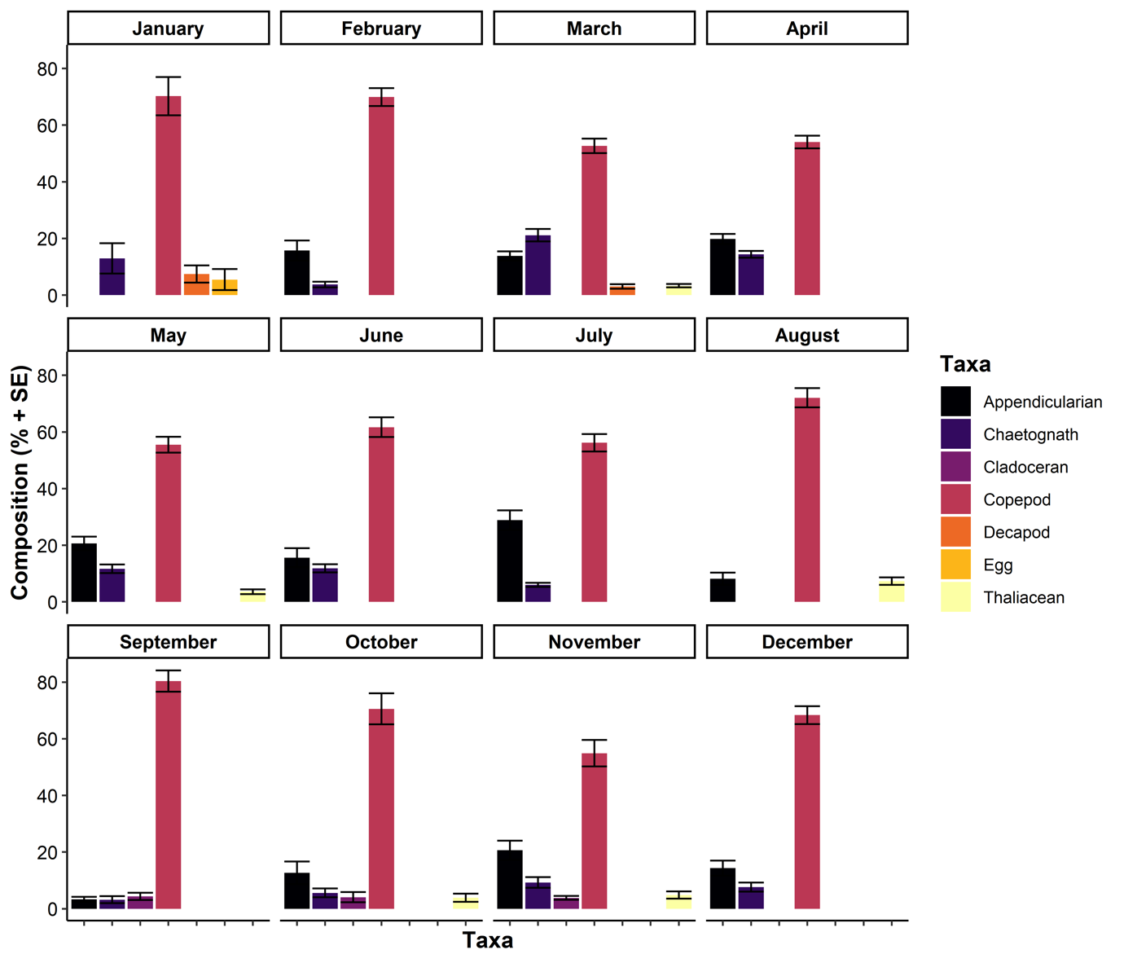

***Figure 3*** *Monthly zooplankton composition based upon continuous plankton recorder data (n = 455) in eastern Australia (28 – 32°S, 152- 155°E, 2009 - 2020). Error bars show ±1 standard error.*

**Comment #7:** 6) Please check the minor problems, such as, P2L33, resulting in "zooplankton ecosystems", usually we don't say zooplankton ecosystems.

**Response:** This phrase has been deleted. Several other minor issues have been resolved with full details provided in the following comments.

**Comment #7:** P7L146, "a research voyage on the on the RV Southern", delete "on the", etc. Please check other parts of the manuscript.

**Response:** The repeated “on the” has been deleted.

**Comment #8:** 7) P31L531-533, "Within the cross-shelf patterns of zooplankton, biomass and mean size also tend to decline with depth in the water column, possibly as a response to light availability (Aarflot et al., 2019)." Light is the limiting factor of phytoplankton, don't understand why the light availability could affect zooplankton.

**Response:** This section has been deleted.

**Reviewer 2:**

**Comment #9:** This study presents an interesting dataset of spatial patterns of zooplankton in pelagic ecosystems associated with the East Australian Current. Study motivation and sampling design seem to be proper and interesting enough. However, overall data analyses and what has been done with results constitutes basic research. In general the study could be much improved and strengthened in itself.

**Response:** We acknowledge that our research may be considered “basic research” as this research has not yet been conducted in the East Australian Current region, and in general cross-shelf studies are rare in the literature, including none in the southwest Pacific. By including 18 international studies a general pattern emerges at the crucial interface of oceans and society. This is also the first paper to present depth resolved transects of zooplankton size-structure across a continental shelf anywhere in the world. We have improved the current study by now discussing the zooplankton composition based upon continuous plankton recorder data and also include a wider range of physical oceanography data in the supplementary as suggested. For further details on how the study has been improved see the following comments.

**Comment #10:** Below I point out a few general comments, while more specific are included in the pdf.

**Response:** Thank you for the comments, we have responded below to all the general and specific comments.

**Comment #11:** - The title says 'zooplankton' but in truth you are analyzing particulates (plankton and detritus), please focus particulates or change the title.

**Response:** The title has been changed to *“Vertically resolved particulate (zooplankton) biomass and size-structure across a continental shelf under the influence of a western boundary current”*

We know from previous research in this area has shown that the vast majority of particulates are zooplankton or marine snow (Suthers et al 2004, Suthers unpublished data) which is an important part of the planktonic ecosystem we are including zooplankton in brackets after particulates to help the readership both understand and find the paper if they are interested in zooplankton dynamics. With such low levels of detritus, we can assume the OPC is accurately quantifying zooplankton (Zhang et al 2000).

Suthers, I. M., Taggart, C. T., Kelley, D., Rissik, D., & Middleton, J. H. (2004). Entrainment and advection in an island's tidal wake, as revealed by light attenuance, zooplankton, and ichthyoplankton. *Limnology and oceanography*, *49*(1), 283-296.

Zhang, X., M. Roman, A. Sanford, H. Adolf, C. Lascara, R. Burgett, Can an optical plankton counter produce reasonable estimates of zooplankton abundance and biovolume in water with high detritus?, *Journal of Plankton Research*, Volume 22, Issue 1, January 2000, Pages 137–150, <https://doi.org/10.1093/plankt/22.1.137>

**Comment #12:** - The manuscript requires greater supporting data to justify the claims made.

**Response:** We respond below to the specific areas where the reviewer suggests additional data are needed. This includes the cross-shelf CTD data such as salinity, nitrate, silicate and oxygen. We have also added information on likely zooplankton composition. See comment #6 for more information.

**Comment #13:** - The manuscript requires restructuring to improve the flow.

**Response:** In line with the reviewer suggestions (detailed below) the manuscript has been restructured. For full details see later responses.

**Reviewer 2 comments from annotated pdf**

**Comment #14:** Line 45: Introduction: Summary

* Please restructure to improve flow (physics, nutrients, chl a and particulates/zooplankton)
* - Please include how top down processes could influence particulate size structure

**Response:** We thank you for these suggestions. We were concerned if we started off with a physics to ecology structure, the reader would not find zooplankton until the 3rd paragraph. Our paper is about zooplankton size-structure, in a physical-nutrient-chlorophyll context rather than about coastal oceanography. With respect, we feel this paper benefits more from the present structure which highlights the biological and ecological importance of firstly continental shelves followed by zooplankton. We have included some additional information in these first paragraphs, about how top-down processes could influence particulate size structure.

The new text is:  
*“Top-down pressure from larger predators can also increase the steepness of the size spectrum as increase the mortality rate of the zooplankton, thereby decreasing the efficiency of energy transfer along the spectrum (Moore and Suthers, 2006; Rossberg et al., 2019).”*

**Comment #15:** Line 49: High chlorophyll a concentrations doesn't always translate to high primary productivity. High rates of primary productivity increase ecosystem productivity...

**Response:** This line has been rephrased to read

*“**These fisheries are supported by high primary productivity (Bakun and Weeks, 2008; Mackinson et al., 2009), often enhanced by coastal processes including upwelling, boundary currents and eddies (D’Croz and O’Dea, 2007; Patti et al., 2008).”*

**Comment #16:** Line 50: References

**Response:** References have been added, see above comment (#15) for new text.

**Comment #17:** Line 52: Requires references

**Response:** Reference add, this line now reads:

*“The high chlorophyll a levels often observed on the continental shelf, particularly the inner shelf (Lucas et al., 2011a, 2011b) are a key driver of zooplankton communities which are a key resource for fisheries (Mitra et al., 2014).”*

**Comment #18:** Line 58: Insight into what?

**Response:** This sentence has been changed to:

*“the size frequency distribution of a community can provide valuable insight into the trophic dynamics of a community (Blanchard et al., 2017)”*

**Comment #19:** Line 64: delete “all”

**Response:** deleted.

**Comment #20:** Line 66: and predation

**Response:** Predation is mentioned at the beginning of this sentence. It reads:

*“The size spectrum implicitly reﬂects the outcome of ecological processes including predation, the growth of individuals through different size classes, and the repopulation of smaller size classes through reproduction (Sprules and Barth, 2015; Andersen et al., 2016; Blanchard et al., 2017)”*

**Comment #21:** Line 68: Here you identity environmental variables that are important to zooplankton size structure. Need to follow through and present this information in this study.

**Response:** As requested we now present information on environmental variables in the current study. We discuss the CTD sampled variables of Nitrate, salinity, oxygen, silicate in the results of each transect. The cross-shelf figures are also now available in the supplementary as Figures S9-S13. Temperature was already included in most of the plots as contour lines.

**Comment #22:** Line 69: Are there any other variables that have been found to explain variation in particle size-spectra?

**Response:** Size spectra are essentially a visualisation of the community response to any environmental factors, integrating many ecological processes as we discussed in the above sentences. We do not think it is worthwhile discussing individual instances of environmental variables being linked to size spectrum and would rather discuss the interpretation of the size spectra and how these may relate to environmental variables.

This section now reads:

*“**While there is variability in interpretations of size spectra depending on the size of particles in the spectrum due to sampling efficiency and natural ‘dome shapes’ in some communities (Marcolin et al., 2013; Rossberg et al., 2019), within the mesozooplankton size range (≈0.2 – 3mm), the elevation of the spectrum reflects the environmental effects which overall primary production and biomass of a community (Moore and Suthers, 2006; Zhou, 2006). Higher primary production and biomass tends to result in a higher elevation (or intercept) with such impacts demonstrated with nutrient input in both estuarine and pelagic ecosystems (Moore and Suthers, 2006; Baird et al., 2008). Steeper slopes in the size-spectrum represent inefficient energy transfer between trophic levels which can occur under both oligotrophic conditions as nutrients become scarce and eutrophic conditions as many bloom taxa are relatively large yet unpalatable which increases the chances of mass sinking of ungrazed blooms leading to reduced efficiency of energy transfer (Atkinson et al., 2020). Top-down pressure from larger predators can also increase the steepness of the size spectrum as increase the mortality rate of the zooplankton, thereby decreasing the efficiency of energy transfer along the spectrum (Moore and Suthers, 2006; Rossberg et al., 2019).”*

**Comment #23:** Line 69: Should also consider how slope values are related to the size of range of particles studied (Marcolin et al 2013).

**Response:** This is a good point, we have made clearer we are referring to the mesozooplankton size range. This section now reads:

*“While there is variability in interpretations of size spectra depending on the size of particles in the spectrum due to sampling efficiency and natural ‘dome shapes’ in some communities (Marcolin et al., 2013; Rossberg et al., 2019), within the mesozooplankton size range (≈0.2 – 3mm), the elevation of the spectrum reflects the environmental effects which overall primary production and biomass of a community (Moore and Suthers, 2006; Zhou, 2006).”*

**Comment #24:** Line 80: Include biophysical processes that influenced observations.

**Response:** This information has now been included. This section now reads:

*“This is similar to the northeast Atlantic where high zooplankton biomasses and steeper zooplankton size spectrum slopes were found in some but not all inshore regions, most often in the lower salinity, higher chlorophyll a coastal water, indicating potential effects of freshwater discharge (Sourisseau and Carlotti, 2006; Irigoien et al., 2009; Vandromme et al., 2014).”*

**Comment #25:** Line 82: Why is this important? Identify the need for cross-shelf vertically resolved observations of particulates.

**Response:** This line has been rephrased to highlight the need for cross-shelf vertically resolved observations. The line now reads:

*“Fewer studies have examined the vertical patterns of zooplankton on continental shelves and this remains a key knowledge gap despite widespread recognition of variation in vertical distributions of zooplankton often attributed to diel vertical migration (Lampert, 1989), and the 3-dimensional influences of continental shelf oceanography (Schaeffer et al., 2013).”*

**Comment #26:** Line 84: What is it about the thermocline influences the distribution of particles.

**Response:** This has been reworded, the thermocline was not attributed to any differences in the original paper and was merely used by the original authors to highlight difference water masses.

The new line is: “During late summer, in the northwest Atlantic, the vertical zooplankton distribution was strongly influenced by water mass with distinct zooplankton communities in the observed warmer and colder water masses (Turner and Dagg, 1983).”

**Comment #27:** Line 87: Contents of this paragraph does not lead to this concluding sentence. There is a number of studies that document the effects that oceanography have on zooplankton/particulate communities.

**Response:** This sentence has been rewritten to better reflect the paragraph. It now reads:

*“**As observations of vertical patterns in zooplankton communities on continental shelves remain uncertain in many regions of the world, it is important to demonstrate how oceanographic features including boundary currents influence the zooplankton community in shallow coastal waters.”*

**Comment #28:** Line 90: The following two paragraphs should come earlier on as they are the primary mechanisms (bottom up drivers) of shelf ecosystem productivity. Add context of:

- physical properties (flooding/upwelling/downwelling/ekman/fronts/uplift/temp/sal/ect)

- nutrients

- aggregation

**Response:** This is very similar to comment #14 (also from reviewer 2). We were concerned if we started off with a physics to ecology structure, the reader would not find zooplankton until the 3rd paragraph. Our paper is about zooplankton size-structure, in a physical-nutrient-chlorophyll context rather than about coastal oceanography. With respect, we feel this paper benefits more from the present structure which highlights the biological and ecological importance of firstly continental shelves followed by zooplankton.

**Comment #29:** Line 98: Need to present this supporting information.

**Response:** This is now supported by references to Schaeffer et al (2013), Everett et al (2014) and Kobari et al (2018). The line now reads:

*“These processes often facilitate a nutrient and productivity gradient from oligotrophic WBCs across the continental shelves into the coast (Schaeffer et al., 2013; Everett et al., 2014; Kobari et al., 2018).”*

**Comment #30:** Line 103: rephrase paragraph - along shelf flows are the primary mechanisms responsible for cross shelf flow dynamics.

**Response:** This section has been rephrased. It now reads:

*“Within both eastern and western boundary currents, cross-shelf flows are often driven by along shore flows and mesoscale oceanographic features (Malan et al., 2020). Cross shelf flows are usually in smaller in magnitude than along-shelf flows but have a disproportional impact on shelf water properties such as plankton and fish distribution (Brink, 2016).”*

**Comment #31:** Line 128 (Methods): Restructure to describe:

* context of the voyage in relation to seasonal variation in oceanography
* Characterise the seasonal variation in EAC dynamics in area of interest (SSH, SST, velocity, chl a) (Is there any data from IMOS moorings that be used w sat data to do this ?)
* Observed vertically resolved cross shelf plots of temperature, salinity, nutrients, chl a/fluorescence, particulates/zooplankton
* Actual zooplankton samples for community composition information would help verify cross shelf plots (are the RMT samples available)?

**Response:** We have restructured the methods section as suggested. We now first address the voyage context in terms of seasonal oceanographic variation. The typical oceanographic features in this region including the EAC are now described before we the use of satellite SST and altimetry data to investigate the seasonality in both oceanography and zooplankton composition at our sampling locations. This section now includes increased discussion of the seasonal dynamics of the EAC and chlorophyll production.

Following the discussion of seasonality, we introduce the sampling procedures including the cross shelf transects with both the SeaSoar and CTD. Then we detail the use of the OPC to generate zooplankton size structure data. Finally, we provide the methods for the global comparison.

The requested vertically resolved plots of temperature, salinity, nutrients, chlorophyll *a* and zooplankton are now all provided.

Actual zooplankton samples for community composition information are not available for this cruise as they have not been sorted for taxonomic composition, only fish larvae were sorted as part of Mullaney *et al.* (2014). Instead, we have provided the likely zooplankton composition from the continuous plankton recorder data within the study area, see comment #6 for more information.

Mullaney, T.J., Gillanders, B.M., Heagney, E.C. and Suthers, I.M. (2014), Entrainment and advection of larval sardine, *Sardinops sagax,* by the East Australian Current and retention in the western Tasman Front. Fish. Oceanogr., 23: 554-567. <https://doi.org/10.1111/fog.12089>

**Comment #32:** Line 153 (Figure 1): Need to add legend for velocity strength, also include SSH and Chl a plot here.

**Response:** A legend for velocity strength has been added to Figure 1. A plot of SSH and Chl has now been added to the supplementary as Figure S1.

The revised Figure 1 is:

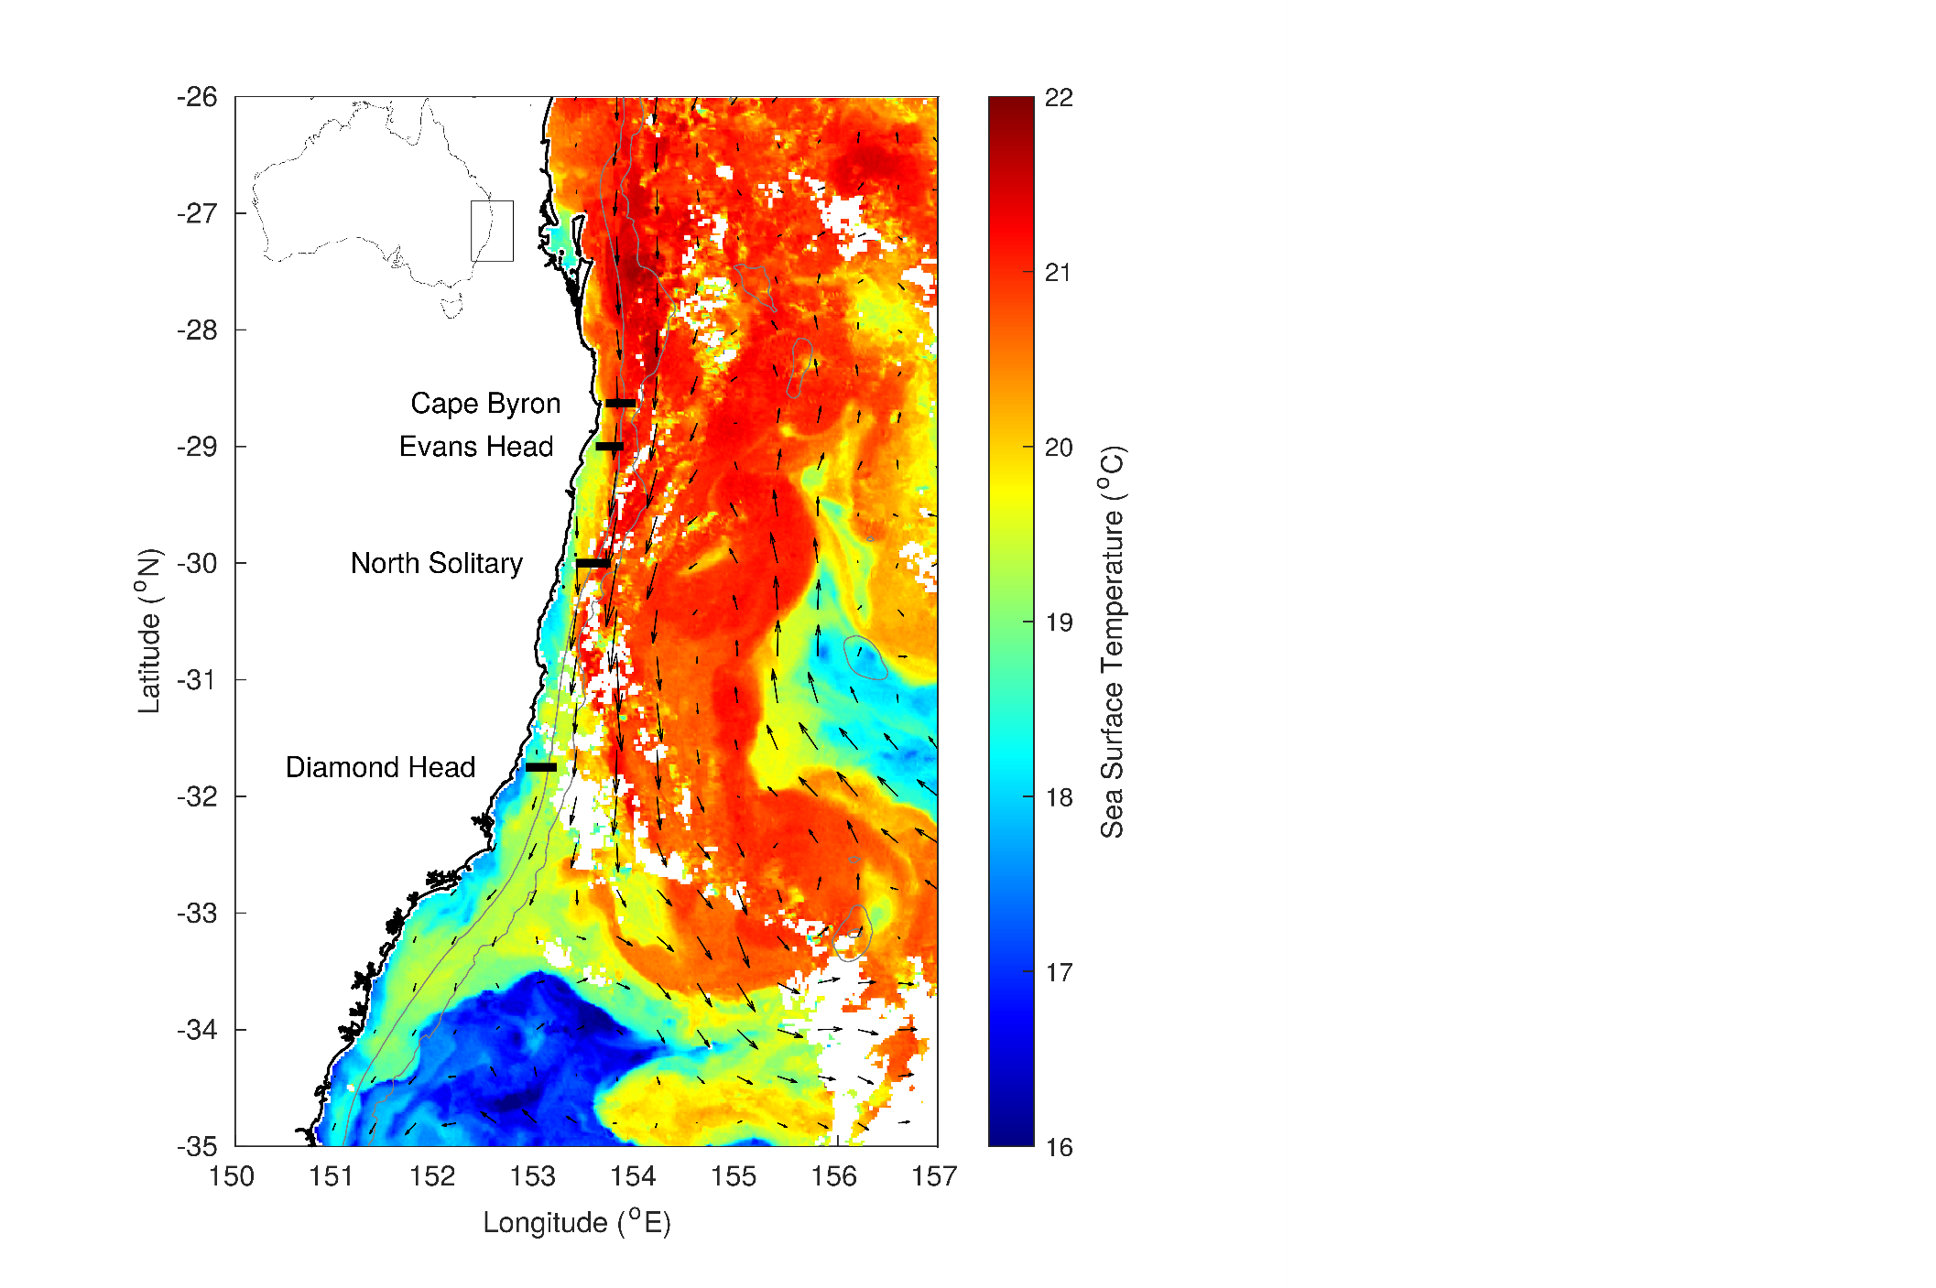

*Figure 1 Locations of the four cross shelf sections which were sampled in September 2004. The sea-surface temperature for 6th September 2004 is shown in colour with velocity arrows from satellite altimetry shown with black arrows. Grey isobaths represent 200 and 2000m depths.*

The new Figure S1 is:

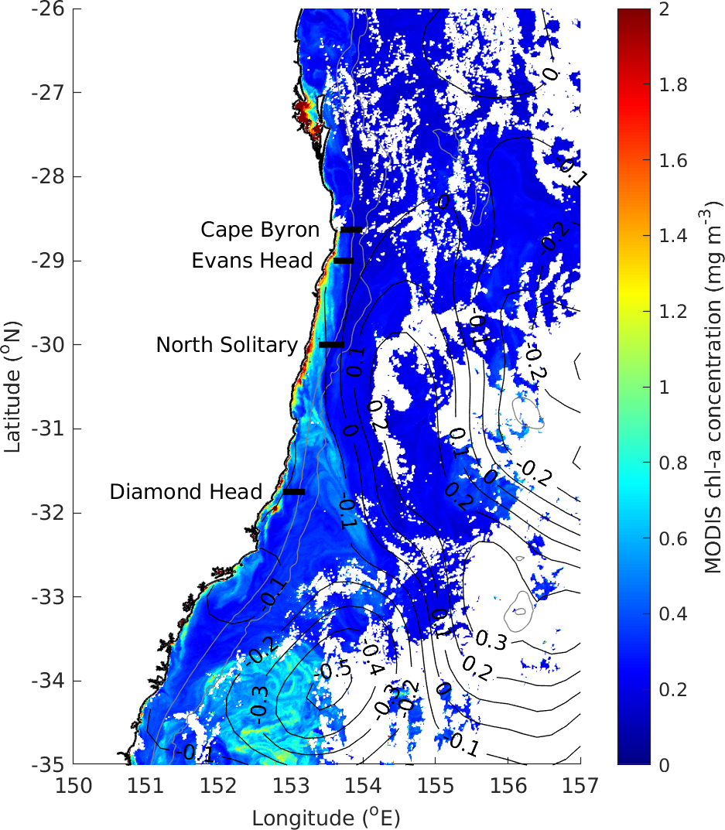

***Figure S1*** *MODIS Chlorophyll a (mg m-3) in the region during our study showing low amounts of Chlorophyll at all the transect sites (black lines) during our study. Black contour lines connect areas of equal sea surface height anomaly.*

**Comment #33:** Line 172 (Table 1): Add a day night field and add diel timing of transects to discussion

**Response:** We have added day/night information to the caption of Table 1 (local time is already in table) and added some discussion of diel timing in the discussion. The new text reads:

*“While this study provides the first high-resolution depth-resolved cross shelf transects, it is limited to the top 100m of the water column and there may be some influence of diel vertical migration of zooplankton on the vertical distribution. Despite this possibility we think the results are robust as two of the samples were conducted at night and two during the day with all four transect showing similar vertical gradients in particulate (zooplankton) properties.”*

**Comment #34:** Line 210: Seasonal variation and cross shelf plots of chlorophyll required in this study

**Response:** Cross shelf plots of chlorophyll *a* are now included in the supplementary material (Figure S11). These plots show overall low concentrations with minimal changes in chlorophyll across the transects. All transects showed between 1 and 1.5 mg m-3 with slight decreases with depth.

Seasonal variation in surface chlorophyll *a* in this region was extensively investigated in Everett et al (2014) based upon satellite data and it shows that the chlorophyll *a* values observed in our study are typical of the region (within 1 SD of the geometric mean Chlorophyll values). Chlorophyll *a* does typically have a spring bloom in but in the latitudinal region in the current study the mean chlorophyll in spring is typically lower than in winter and the spring is more of a moderate bloom (typically 27 -79 % increase on the annual average). The major spring bloom and seasonality patterns occurs to the south of our study (south of 32°S). Some of this information has now been highlighted better in our manuscript. The introduction now reads:

*“The western boundary current of the South Pacific is the East Australian Current which generates eddies (Everett et al 2012) and drives upwelling as it interacts with the continental shelf (Roughan and Middleton, 2002). These oceanographic processes influence nutrient availability and the biomass of chlorophyll a creating consistent observations where the spring bloom is typically south of 34°S with the northern areas having more consistent chlorophyll a levels (Everett et al., 2014), yet there are no studies investigating the influence of the East Australian Current on higher trophic levels including zooplankton.”*

For the reviewer we are here providing Figure 4 from Everett et al, showing the long term time series of chlorophyl in this region. Showing that spring (September) 2004 is largely typical. We have added the following line to the methods section:

*“The observed chlorophyll a levels in the area are also typical of those observed in September (Everett et al., 2014).”*

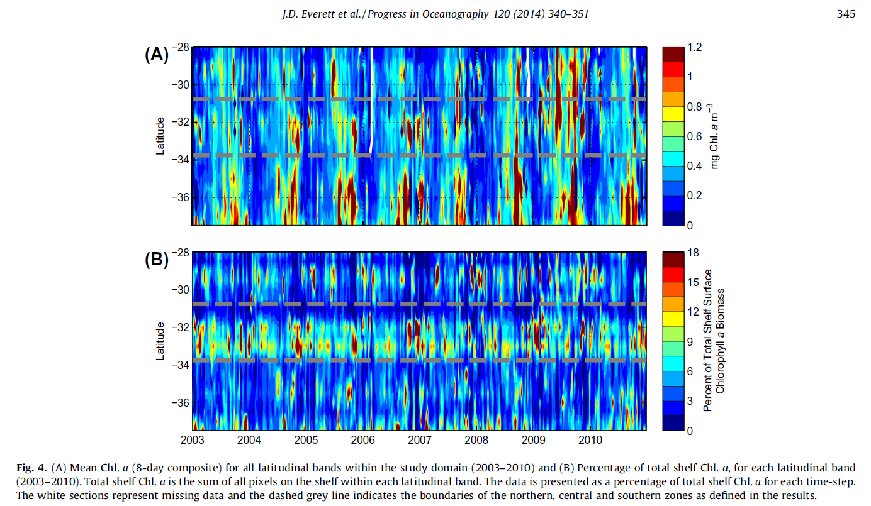

The typical nature of 2004 is also shown in Figure 5a of Everett et al, again pasted below:  
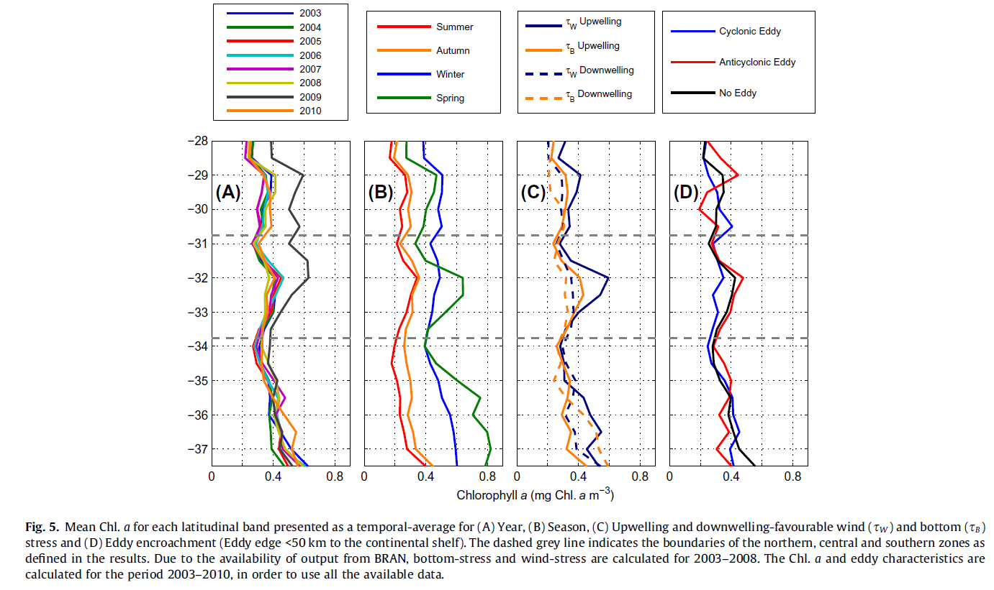

**Comment #35:** Line 215: I'd prefer OPC observations referred to as particulates and in-situ observations of zooplankton (RMT net samples) used to verify OPC observations. Is this possible?

**Response:** The zooplankton samples collected in this voyage have not been inspected for taxonomic composition (except larval fish) but some samples were independently analysed with a lab based OPC with the resulting biomass and size spectrum estimates comparable to that observed in our study with the towed OPC (Mullaney et al 2014). While being sorted for larval fish there was no noticeable sediment or inorganic detritus.

Previous plankton sampling in the region in which samples were inspected onboard the voyages has shown that inorganic particulate matter is extremely rare (<1%) and almost all collected “particles” consist of whole or fragmented zooplankton with it being likely that significant fragmentation of zooplankton is occurring in the net during the collection process. This fragmentation problem is not relevant for the towed OPC samples and can be seen as an advantage. We prefer to refer to the particles as zooplankton as we are confident >95% of particles from the OPC are in act zooplankton and if not they would be part of the planktonic ecosystem comprising of marine snow which is an essential part of the carbon cycle (Turner, 2015).

Previous work in this region (including this OPC dataset) has shown that zooplankton biomass modelled off the OPC data correlates significantly with biomass derived from the CPR despite the methodology differences (White 2018). This lends additional support the argument that the majority of ‘particles’ measured are in fact zooplankton. As a compromise, we now refer to the ‘particles’ as particulates (zooplankton)

Mullaney, T.J., Gillanders, B.M., Heagney, E.C. and Suthers, I.M. (2014), Entrainment and advection of larval sardine, Sardinops sagax, by the East Australian Current and retention in the western Tasman Front. Fish. Oceanogr., 23: 554-567. <https://doi.org/10.1111/fog.12089>

Turner, J. T. (2015). Zooplankton fecal pellets, marine snow, phytodetritus and the ocean’s biological pump. *Progress in Oceanography*, *130*, 205-248.

White (2018) The spatial distribution of zooplankton production in the western Tasman Sea: A size-spectra approach. Masters Thesis (UNSW Australia) http://handle.unsw.edu.au/1959.4/60494

**Comment #36:** Line 224: Biovolume is commonly used in the literature, useful for comparisons and to be consistent. Abundance would be a useful metric to include as well for ecological and global comparison purposes.

**Response:** We have now included plots of cross-shelf Abundance as supplementary material as it is highly correlated with biomass (and biovolume) and geometric mean size (as expected).

We have retained the original wording of biomass for the majority of our paper for 4 main reasons.

1. Biomass aligns with the recently published compilation of zooplankton data in Australia (including LOPC and OPC derived biomass). This database is detailed here: McEnnulty, F.R., Davies, C.H., Armstrong, A.O. *et al.* A database of zooplankton biomass in Australian marine waters. *Sci Data* **7,**297 (2020). <https://doi.org/10.1038/s41597-020-00625-9>
2. Biomass is more readily understand and is more tangible to marine scientists in general, particularly those concerned with ecosystem modelling which often uses biomass as a key input parameter (eg. Ecopath models are built upon biomass)
3. Biomass is also commonly reported in the literature for OPC/LOPC studies, for example:
   1. Espinasse, B. et al. Conditions for assessing zooplankton abundance with LOPC in coastal waters. Progress in Oceanography 1–0 (2017) doi:10.1016/j.pocean.2017.10.012.
   2. Kwong, L., Suchy, K., Sastri, A., Dower, J. & Pakhomov, E. Comparison of mesozooplankton production estimates from Saanich Inlet (British Columbia, Canada) using the chitobiase and biomass size spectra approaches. Mar Ecol Prog Ser 655, 59–75 (2020).
   3. Krupica, K. L., Sprules, W. G. & Herman, A. W. The utility of body size indices derived from optical plankton counter data for the characterization of marine zooplankton assemblages. Continental Shelf Research 36, 29–40 (2012).
4. Due to the conversion of ESD to biomass assuming plankton have the density of water, our biomass value (mg m-3) is directly convertible to biovolume (mm3 m-3) and we have added this information to the legend of the cross-shelf biomass plot and made specific reference to this in the methods section.

The new text now reads:

*“Under our assumption that our particles have the density of water, 1mg is therefore equivalent to 1mm3, resulting in our $Biomass \left(mg m^{-3}\right)$ being equivalent to biovolume (mm3 m-3) and we have labelled our plot axes as such.”*

The revised Biomass/Biovolume plots is as follows:

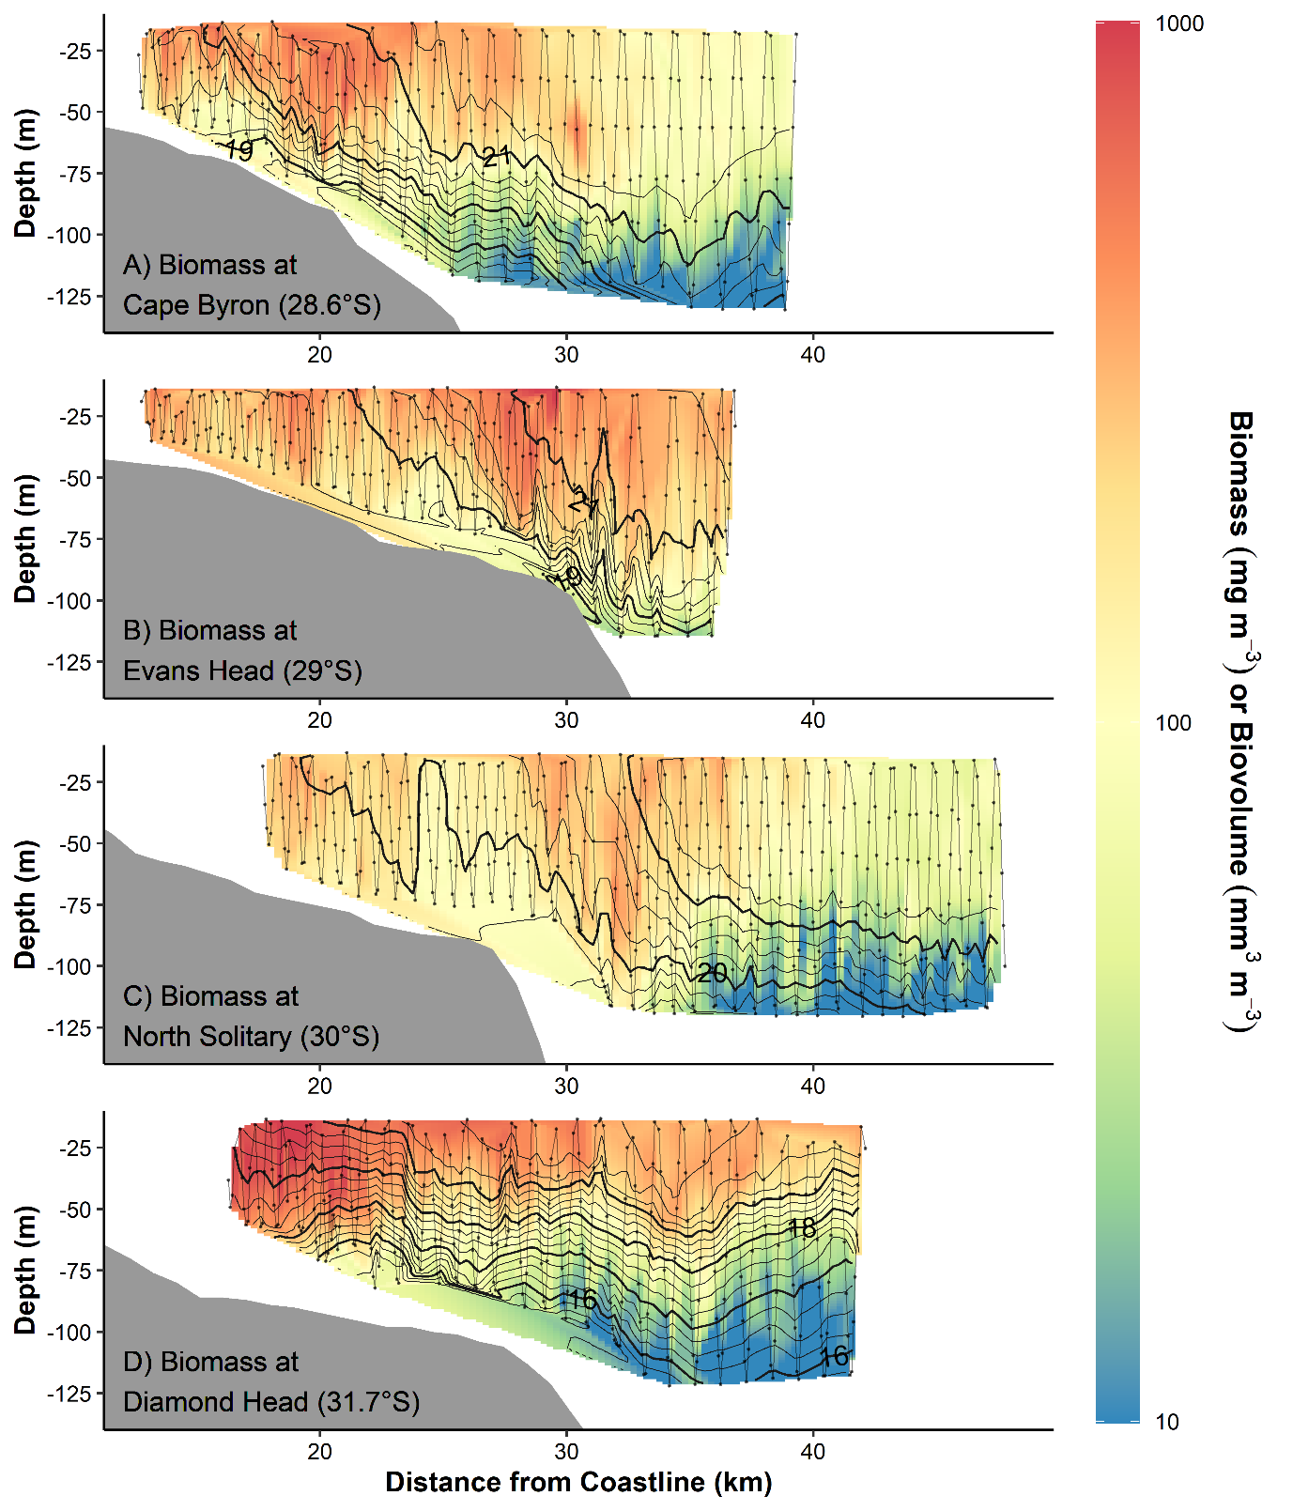

***Figure 5*** *Zooplankton biomass (mg m-3) and biovolume (mm m-3) distributions from the four cross shelf transects (Figure 1). Transects were conducted from inshore to offshore with an undulating towed body with the path shown by the grey line with midpoints of each sample shown as dots. Temperature (°C) isotherms are shown in black. Note biomass the log transformed colour scale.*

The new supplementary abundance plot is as follows:

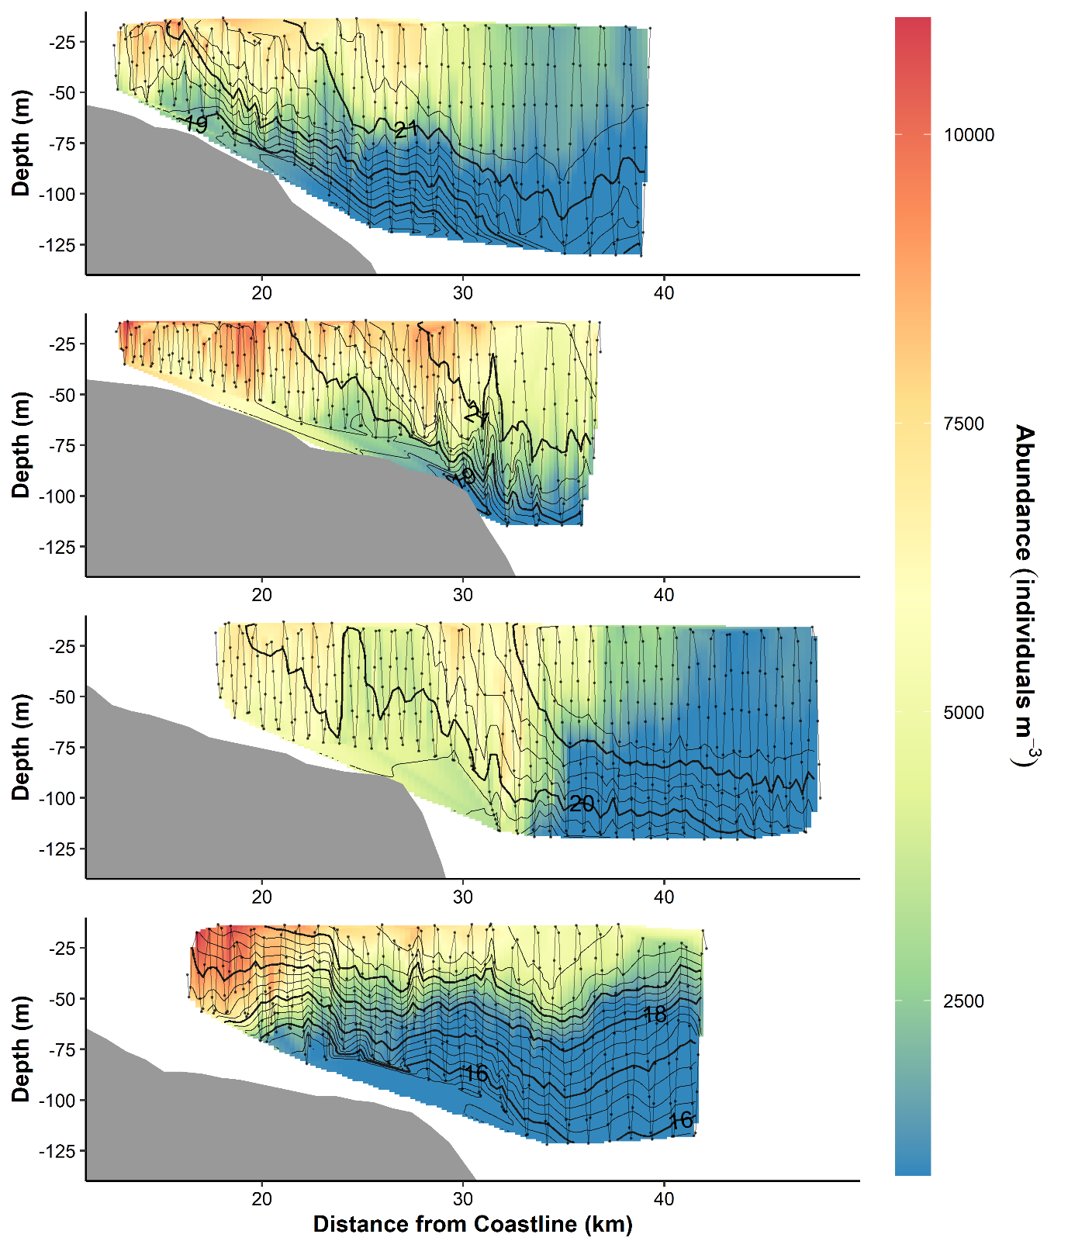

***Figure S7*** *Cross-shelf interpolations of zooplankton abundance (individuals m-3). Measurements were taken as part of a CTD transect (data points shown as dots). Black lines connect areas of equal temperature (°C). Transects were conducted from inshore to offshore with an undulating towed body with the path shown by the grey line with midpoints of each sample shown as dots. Temperature (° C) isotherms are shown in black.*

**Comment #37:** Line 236: Common practice in literature is to refer to as biovolume.

**Response:** See comment #36.

**Comment #38:** Line 245: Many of these studies describe results in context of environmental and ecological covariates. Please include some way to characterise environmental and ecological context of studies.

**Response:** Similar to the point raised by reviewer 1 in comment #2, we agree that the studies which we have combined in our global analysis are from a variety of locations, incorporating different environmental and ecological contexts. With 19 different studies it is not feasible to address the environmental and ecological contexts in a meaningful way without substantially increasing the length of the paper. Instead, we have made clearer the links between all the studies by highlighting the fundamental process that links all the continental shelf studies.

The common fundamental process that unites all studies is the nutrient enrichment that occurs in all near-coastal waters, due to many different upwelling processes (coastal winds, reverse Ekman, or topographic effects) and estuarine processes and run-off from land. Therefore, western boundary currents do have a major influence on coastal enrichment, but are not the only cause. This drives the ubiquitous “green-ribbon” (Lucas et al. 2011) in chlorophyll-a observed along most coasts world-wide, and our study together with related work establishes a general pattern in zooplankton size and abundance. We have now made a point in the discussion of how the general patterns in zooplankton are likely due to coastal nutrient enrichment which can be caused by many mechanisms. The discussion now states:

*“These horizontal trends in the particulate (zooplankton) size-structure are consistent with the patterns in size-structure across other continental shelves and likely are an outcome of nutrient enrichment which tends to occur on continental shelves. This enrich can come from a variety of sources including cross-shelf flows and sporadic upwelling processes driven by ocean currents and coastal winds (Roughan and Middleton, 2002; Malan et al., 2020), estuarine process (Morris et al., 1995) or run-off from land (Correll et al., 1992).”*

We have also added some discussion about how the cross-shelf gradients (produced as discussed above) are a key component of the observed zooplankton dynamics:

*“Despite different regional dynamics, cross-shelf and vertical gradients in water-masses, here driven by the EAC and uplift, seem to be the dominant factor for the patterns observed at various locations worldwide.”*

In the methods section we have also made clearer the reasoning behind using all these studies in this way. The new text reads:

*“While each continental shelf is unique and the ecological and environmental context of each study will differ, nutrient enrichment is common along all continental shelves. This enrichment comes from a variety of sources including upwelling (Roughan and Middleton, 2002; Malan et al., 2020), run-off (Correll et al., 1992) and estuarine processes (Morris et al., 1995) but for the context of our global comparison we are only concerned with the resulting pattern of zooplankton across the continental shelves.”*

**Comment #39:** Line 261: As suggested in the methods sections please restructure to describe:

* Seasonal variation in EAC dynamics (distance from shore, velocity, SSH, SST, chl a)
* Observations of vertically resolved cross shelf plots of temperature, salinity, nutrients, chl a/fluorescence, particulates/zooplankton
* In-situ Zooplankton samples for community composition information would help verify cross shelf plots (RMT)?

**Response:** As suggested we have restructured the results section to first cover the seasonal variation in regional oceanography (and zooplankton composition) before addressing the specifically sampled cross-shelf transects. The results section ends with the global comparison section.

**Comment #40:** Line 266: rephrase/remove

**Response:** This line has been rephrased, it now reads:

*“At the time of our sampling, the three northern most transects (north of 30°S) all crossed from cooler inshore waters into warm EAC water but the southern transect (Diamond Head 31.75°S) was located south of where the EAC begins to separate from the shelf (“the separation zone”; Figure 1).”*

**Comment #41:** Line 276: Report EAC centered at xx km offshore above the xxx m depth contour. In the discussion cover how the center of EAC was located x distance from shore / above x depth contour. And how its proximity to coast the depth of water it flowed in influenced uplift?

**Response:** This section has been rephrased as suggested and now reads:

“The northernmost transect at Cape Byron (28.6°S) was dominated by the EAC which had a strong alongshore flow (1.50 m s-1; Figure 4). The EAC was centred 27.6km offshore, above the 200 m isobath. Most of the continental shelf was flooded by warm EAC water (Figure 4). There was evidence of uplift with the 21° C isotherm rising to the surface from 70 m depth over 5 km and the 20° C isotherm rising to the surface from 100 m depth over 15 km. The EAC showed slight onshore movement which increased offshore and with depth, peaking between 100 and 200 m depth (up to 0.26 m s-1, Figure S4).”

We have now added this discussion to the discussion. The new text reads:

*“At Cape Byron and Evans Head, the EAC was in high proximity to the continental slope and the lack of upwelling-favourable wind stress (Figure S3) suggests that the observed isotherm uplift is likely to be current-driven, as shown in Schaeffer et al. (2014). This was contrasted by North Solitary where the EAC was further offshore and it was likely the uplift was at least partially caused by the upwelling favourable winds in the hours prior to sampling. As a contrast, Diamond Head which was located south of the EAC separation and therefore free from its influence was largely homogenous with little horizontal structure and limited uplift of isotherms.”*

**Comment #42:** Line 279: Include data from along and cross shelf flow to make this point.

**Response:** This section has been rephrased and the requested along and cross shelf data are referred to as part of the revised paragraph. See above comment for new text.

**Comment #43:** Line 285: Data does not support the strength of this statement.

**Response:** This statement has been deleted.

**Comment #44:** Line 291: This paragraph would benefit from consideration of cross shelf patterns in temperature, salinity, nutrients, chl a/ fluorescence

**Response:** This consideration in temp, salinity, chl a and fluorescence has now been added. This section now reads:

*“No depth resolved cross shelf chlorophyll a or nutrient data was available for the Cape Byron transect but there was a gradient in both salinity and temperature across the shelf. Warmer saltier water was found in offshore water, with the salinity both showing similar uplift onto the shelf as described above for the temperature isotherms (Figure S9).”*

**Comment #45:** Line 295 (Figure 2): Describe the direction of flow +- represents in the caption.

**Response:** This information has been added to the caption. The caption now reads:

***“Figure 2:*** *Alongshore (towards ~195°, minor variation in coastline angle between sites) velocity across the four cross shelf transects (Figure 1), from the vessel’s Acoustic Doppler Current Profiler. Grey lines join areas of equal velocity.”*

**Comment #46:** Line 319: Rephrase

**Response:** This has been rephrased and now reads:

*“The transect at Evans Head (29°S) extended only 5km past the continental shelf edge but was still largely influenced by the EAC. The EAC was centred 36.1km from the offshore above the 220m contour. The EAC had a strong along-shore flow (1.47 m s-1; Figure 4).”*

**Comment #47:** Line 322: Report EAC centered at xx km offshore above the xxx m depth contour. In the discussion cover how the center of EAC was located x distance from shore / above x depth contour at each station. And how its proximity to coast / depth of water it flowed over influenced uplift.

**Response:** This has been rephrased as suggested. It now reads: “The transect at Evans Head (29°S) extended only 5 km past the continental shelf edge but was still largely influenced by the EAC. The EAC was centred 36.1 km from the offshore above the 220 m contour. The EAC had a strong along-shore flow (1.47 m s-1; Figure 2). The EAC showed offshore movement (0.27 m s-1) which increased with distance offshore (Figure S4). There was strong current driven uplift of the isotherms inshore of the EAC with the 21 °C isotherm rising to the surface from 70 m depth over 6 km and the 20 °C isotherm rising to the surface from 100 m depth over 15 km.”

We have now added this discussion to the discussion. The new text reads:

*“At Cape Byron and Evans Head, the EAC was in high proximity to the continental slope and the lack of upwelling-favourable wind stress (Figure S3) suggests that the observed isotherm uplift is likely to be current-driven, as shown in Schaeffer et al. (2014). This was contrasted by North Solitary where the EAC was further offshore and it was likely the uplift was at least partially caused by the upwelling favourable winds in the hours prior to sampling. As a contrast, Diamond Head which was located south of the EAC separation and therefore free from its influence was largely homogenous with little horizontal structure and limited uplift of isotherms.”*

**Comment #48:** Line 323: Include data on along and cross shelf flow to support this point.

**Response:** This information is now included in this paragraph. It reads:” The transect at Evans Head (29°S) extended only 5km past the continental shelf edge but was still largely influenced by the EAC. The EAC was centred 36.1km from the offshore above the 220m contour. The EAC had a strong along-shore flow (1.47 m s-1; Figure 2). The EAC showed offshore movement (0.27 m s-1) which increased with distance offshore (Figure S4). There was strong current driven uplift of the isotherms inshore of the EAC with the 21 °C isotherm rising to the surface from 70 m depth over 6 km and the 20 °C isotherm rising to the surface from 100 m depth over 15 km.”

**Comment #49:** Line 324: This paragraph would benefit from the inclusion of cross shelf patterns in temperature, salinity, nutrients, chl a/ fluorescence

**Response:** This has now been added. The paragraph reads:

*“The zooplankton size structure varied along the transect. The EAC was warmer and saltier compared to the inner shelf water (Figure S9). There was also a slight gradient in Nitrate and chlorophyll with higher levels of both in the inshore waters (3 mmol m-3 and 1.35 mg m-3 respectively; Figures S10 & S11). Around the front between the continental shelf water (< 21 °C) and the warm (> 21 °C) EAC water the zooplankton community showed a similar GMS of ≈450 µm ESD to that observed at the northern Cape Byron transect but had a higher biomass and shallower pareto distribution shape parameter c (≈-1; Figures 3, 4 & 5).”*

**Comment #50:** Line 327: Size structure of particulates, community refers to species or functional groups. Data does not support this statement

**Response:** This has been rephrased. It now reads:

*“The zooplankton size structure varied along the transect.”*

**Comment #51:** Line 331: Results are not as clear-cut as reported

**Response:** This section has been rephrased. It now reads: “The zooplankton size structure varied along the transect. The EAC was warmer and saltier compared to the inner shelf water (Figure S9). There was also a slight gradient in Nitrate and chlorophyll with higher levels of both in the inshore waters (3 mmol m-3 and 1.35 mg m-3 respectively; Figures S10 & S11). In the warmer offshore water the zooplankton biomass and geometric mean size was similar that offshore at Cape Byron while in the cool inshore waters, there was again high zooplankton biomass (Figure 5), but the community had shifted towards smaller particles which resulted in a steeper c (< -1.3; Figures 4 & 5). There was also low abundance in the deeper samples (Figure S7).”

**Comment #52:** Line 334: Abundance data would be useful

**Response:** Abundance data has been added. See above response for example.

**Comment #53:** Line 337: Include numbers of along and cross shelf flow to make this point.

**Response:** This information has been added. This section now reads:

*“**The EAC was centred of the EAC was 37.7 km offshore (alongshore flow 1.59 m s-1), located above the 310 m bathymetry contour (Figure 4).* *This uplift could potentially have been driven by the upwelling favourable winds in the hours leading up to sampling (Fig S3). The offshore waters of the EAC showed slight onshore movement, at depths of 100-150m (0.15 m s-1; Figure S4).”*

**Comment #54:** Line 340: Report EAC centered at xx km offshore above the xxx m depth contour. In the discussion cover how the center of EAC was located x distance from shore / above x depth contour. And how its proximity to coast the depth of water it flowed in influenced uplift?

**Response:** This has been rephrased as suggested. It now reads: “The EAC was centred of the EAC was 37.7 km offshore (alongshore flow 1.59 m s-1), located above the 310 m bathymetry contour (Figures 4)”.

We have now added this discussion to the discussion. The new text reads:

*“At Cape Byron and Evans Head, the EAC was in high proximity to the continental slope and the lack of upwelling-favourable wind stress (Figure S3) suggests that the observed isotherm uplift is likely to be current-driven, as shown in Schaeffer et al. (2014). This was contrasted by North Solitary where the EAC was further offshore and it was likely the uplift was at least partially caused by the upwelling favourable winds in the hours prior to sampling. As a contrast, Diamond Head which was located south of the EAC separation and therefore free from its influence was largely homogenous with little horizontal structure and limited uplift of isotherms.”*

**Comment #55:** Line 342: Rephrase

**Response:** This has been rephrased. It now reads: “The offshore waters of the EAC showed slight onshore movement, at depths of 100-150m (0.15 m s-1; Figure S4).”

**Comment #56:** Line 343: This paragraph would benefit from the inclusion of cross shelf patterns in temperature, salinity, nutrients, chl a/ fluorescence

**Response:** This has now been included. The paragraph now reads:

*“Biomass and abundance generally decreased with distance offshore and with depth (Figures 5, S5 & S6 & S7). The warmer water, located offshore, contained low biomass with a shallow pareto distribution shape parameter c (-0.9) and GMS of ~450 µm (Figures 5, 6 & 7). Zooplankton in cooler water < 20 °C had a much smaller GMS (~400µm ESD) resulting in a steeper c (< -1.3). This was particularly evident where the 20°C isotherm reach the surface ~24 km from the coastline, bringing with it a highly productive zooplankton community (Figures 6 & 7). This peak also aligned with a minor peak in chlorophyll a (1.45 mg m-3; Figure S11). North Solitary showed evidence of uplift with the small GMS community from deep uplifted to the surface. The uplift could have resulted from the close-by EAC and the short upwelling-favourable wind a few hours before sampling. The deep cold water (< 16°C) had higher levels of Nitrate and Silicate (Figure S10 & S12), but this does not appear to have been lifted to the surface waters with the surface waters low in nutrients across the transect.”*

**Comment #57:** Line 344: Rephrase

**Response:** This line has been rephrased. See comment #56 (above) for full paragraph.

**Comment #58:** Line 344: particle biomass

**Response:** This line has been rephrased. See comment #56 for full paragraph.

**Comment #59:** Line 345: Data does not support this.

**Response:** Figures S5 and S6 clearly support this pattern, particularly on the log scale and are pasted here for reference:

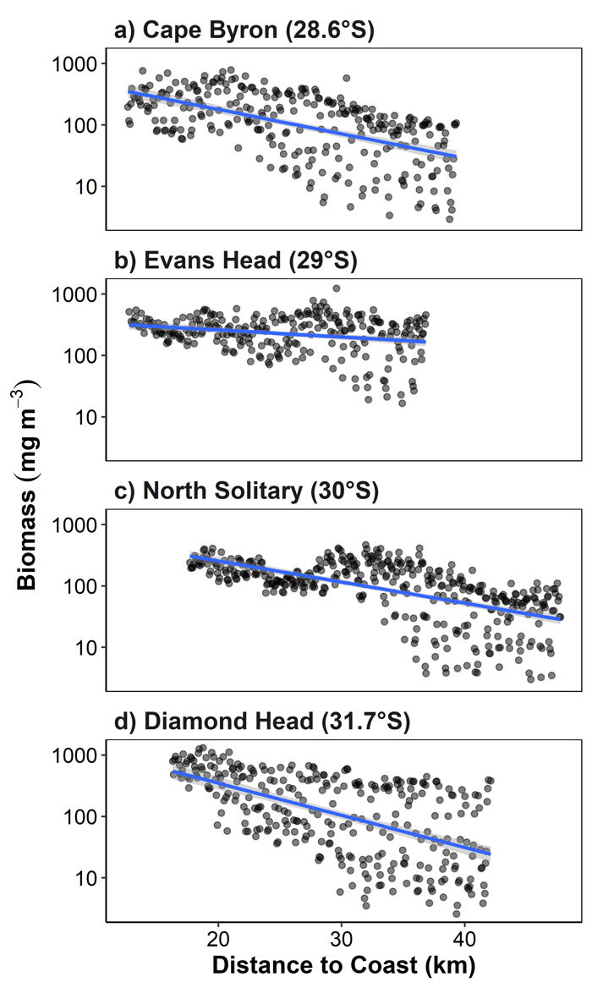

**Figure S5** Biomass by distance from the coast for the four transects. Note the log10 transformed y-axis. Each dot represents a 6 s integration from the OPC mounted on the undulating towed body. Blue lines represent the linear trend line with the 95% confidence intervals shown in grey.

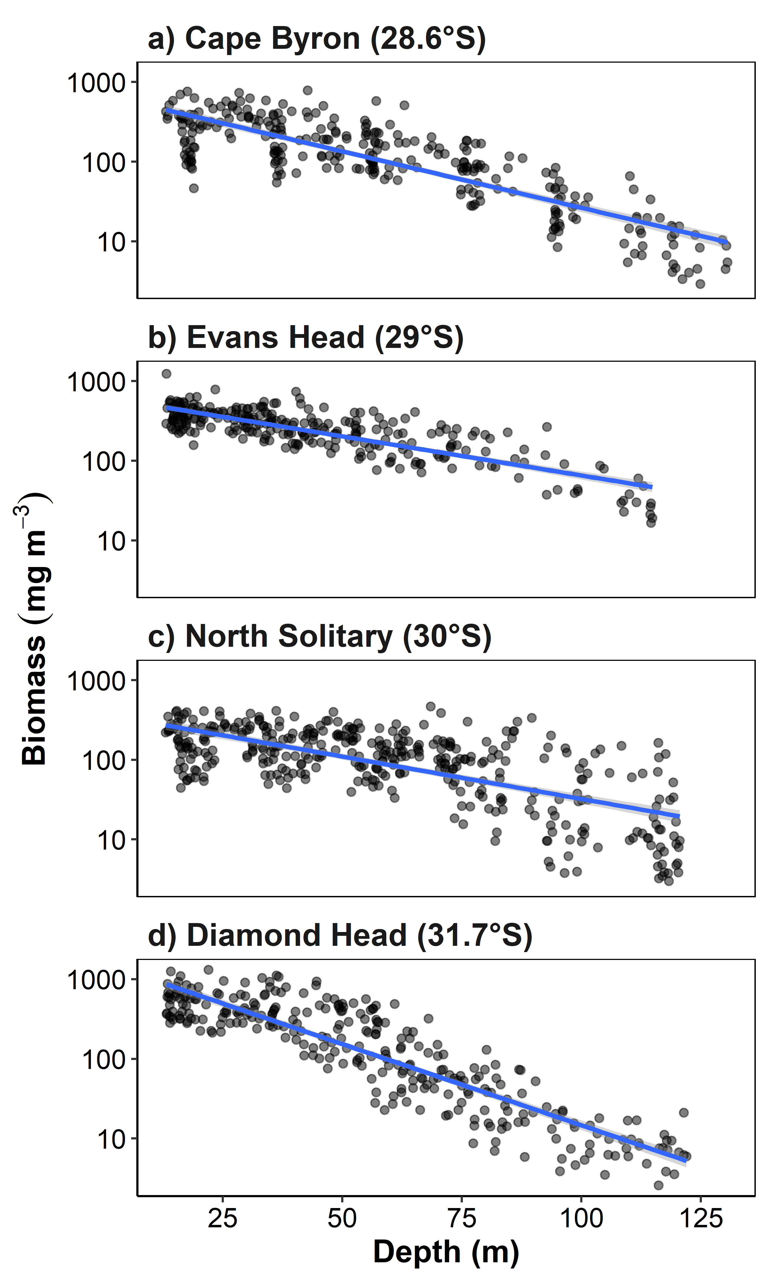

**Figure S6** Biomass by sample depth for the four transects. Note the log1­0 transformed y-axis. Each dot represents a 6 s integration from the OPC mounted on the undulating towed body. Blue lines represent the linear trend line with the 95% confidence intervals shown in grey.

**Comment #60:** Line 345: Rephrase

**Response:** This line has been rephrased. See comment #56 for full paragraph.

**Comment #61:** Line 348: Data does not support this statement.

**Response:** This line has been deleted.

**Comment #62:** Line 357: This paragraph would benefit from the inclusion of cross shelf patterns in temperature, salinity, nutrients, chl a/ fluorescence

**Response:** This information has been added. The paragraph now reads:

*“The most southern transect located at Diamond Head (31.75°S) was not influenced by the EAC which had separated from the coast to the north and was characterised by a more homogeneous water mass. Here, the alongshore velocities were low (< 0.43 m s-1, Figure 4) with low onshore movement of water (0.11 m s-1) in the surface waters and offshore movement (0.27 m s-1) in the deeper waters (Figure S4). The lack of horizontal variation was reflected in the Nitrate, Silicate, temperature and salinity with almost all variation being observed with depth (Figures S9, S10, S12). Chlorophyll and Oxygen showed small peaks (1.2 mg m-3 and 240 mmol m-3 respectively; Figures S11 & S13) at the surface near the beginning of the transect. There was minor uplift of the temperature isotherms with all isotherms rising approximately 20 – 40 m as they came onto the continental shelf. This uplift is likely caused by the separation of the EAC from the coast to the north, generating uplift through the creation of eddies near Diamond Head rather than current driven uplift observed at the northern EAC influenced sites (Roughan and Middleton, 2002; Schaeffer and Roughan, 2015).”*

**Comment #63:** Line 364: Broad summary "This transect had the highest observed biomass of particles..."

**Response:** This has been added to the beginning of the paragraph as suggested. It now reads:

*“This transect has the highest observed biomass of particles (1000 mg m-3), particularly inshore (Figure 5).”*

**Comment #64:** Line 365: delete “zooplankton community”

**Response:** This has been rephrased. It now reads:

*“The zooplankton size structure was not clearly related to water masses reflecting the more homogenous water mass here”*

**Comment #65:** Line 371: Synthesis of EAC position relative to distance from shore and depth, along and cross shelf flow and how it determines uplift at transect is required

**Response:** We have added a comment about the relative influence of the EAC on cross-shelf flow at the different sites. This section now opens with:

*‘The influence of the EAC varied between the three transects. The three northern transects were influenced strongly by the EAC, particularly the offshore sections while the Diamond Head transect was not influenced by the EAC. At the two northern sites the EAC was located close to the continental shelf and likely drove current driven upwelling. In contrast at the North Solitary site, the EAC was located further offshore, and the weaker observed uplift was potentially caused by wind driven upwelling (Fig S3).”*

**Comment #66:** Line 371: See comment about restructure

**Response:** The results section was restructured as suggested and now starts with a discussion of seasonality, followed by the transect observations then a synthesis of the observations.

**Comment #67:** Line 374: Rephrase

**Response:** This has been rephrased. It now reads:

*“The alongshore velocity at all sites was reduced between April and August before increasing in Spring (when our observations were taken) and Summer. This seasonality is consistent with previous findings from higher-resolution HF radar observations around 30°S (Archer et al., 2019).”*

**Comment #68:** Line 376: Rephrase

**Response:** This has been rephrased. It now reads:

*“The Cape Byron, North Solitary and Diamond Head transects had higher zooplankton biomasses observed in continental shelf waters with declines offshore and with depth in the top 100m of the water column (Figures S5 & S6). The transect at Evans Head did not show a noticeable decline in biomass with distance from the coast but this transect did not extend past the edge of the continental shelf where the declines were seen in the other 3 transects.”*

**Comment #69:** Line 379: Data does not support this.

**Response:** This statement has been deleted.

**Comment #70:** Line 385: I suspect that an alternative mechanism might have generated localised uplift, 24km from the coast at Nth Solitary, as pattern is not observed in alongshore and cross shelf velocity profiles.

**Response:** North Solitary showed evidence of uplift with the small GMS community from deep uplifted to the surface. The uplift could have resulted from the close-by EAC and the short upwelling-favourable wind a few hours before sampling. We have added this to the manuscript where the lines read:

*“**North Solitary showed evidence of uplift with the small GMS community from deep uplifted to the surface. The uplift could have resulted from the close-by EAC and the short upwelling-favourable wind a few hours before sampling.”*

**Comment #71:** Line 434: Particulate

**Response:** This has been changed to *“We found consistent declines from inshore to offshore in particulate (zooplankton) biomass”*

**Comment #72:** Line 434: biovolume

**Response:** See response to comment #36 regarding biovolume and biomass.

**Comment #73:** Line 434: ? altered

**Response:** This has been rephrased. It now reads:

*“**We found consistent declines from inshore to offshore in particulate (zooplankton) biomass and variation in size-structure both horizontally and vertically across the narrow continental shelf off eastern Australia.”*

**Comment #74:** Line 437: Need to present and describe results in context of along and cross shelf flow.

**Response:** This sentence is part of the summary paragraph to open the discussion. We have now expanded on this in the following paragraph. This paragraph now begins with:

*“The cross-shelf observations of chlorophyll a and nutrients showed little patterns across our transects the majority of variation in water properties being observable through temperature and salinity. The warm salty EAC dominated the upper 100m of the offshore portions of the three northern transects with cooler inner shelf water. At Cape Byron and Evans Head, the EAC was in high proximity to the continental slope and the lack of upwelling-favourable wind stress (Figure S3) suggests that the observed isotherm uplift is likely to be current-driven, as shown in Schaeffer et al. (2014). This was contrasted by North Solitary where the EAC was further offshore and it was likely the uplift was at least partially caused by the upwelling favourable winds in the hours prior to sampling. As a contrast, Diamond Head which was located south of the EAC separation and therefore free from its influence was largely homogenous with little horizontal structure and limited uplift of isotherms.”*

**Comment #75:** Line 440: Particulate biovolume

**Response:** This has been changed to: *“Particulate (zooplankton) biomass”*.

**Comment #76:** Line 441: Rephrase

**Response:** This has been rephrased to:

*“Particulate (zooplankton) biomass and mean size was generally reflective of the horizonal and vertical structure of the water. Distinct from the warmer offshore EAC, the cooler shelf water revealed a zooplankton community with higher biomass, smaller geometric mean size and steeper size spectrum slope (Figures 5, 6 & 7).”*

**Comment #77:** Line 447: Need to present data to support this statement

**Response:** This data is presented in Figures 5, 6 & 7. This is now referred to in text as:

*“Distinct from the warmer offshore EAC, the cooler shelf water revealed a zooplankton community with higher biomass, smaller geometric mean size and steeper size spectrum slope (Figures 5, 6 & 7).”*

**Comment #78:** Line 448: add data to support this statement.

**Response:** The data to support this statement are reflected by the citations now provided. This is now referred to in text as:

*“These observations are consistent with higher chlorophyll a on the continental shelf (Everett et al., 2014) and are likely driven by uplift of the cooler water due to the EAC interacting with the sloping topography (Schaeffer et al., 2014; Schaeffer and Roughan, 2015).”*

**Comment #79:** Line 451: Go on and discuss how planktivorous fish are associated with shelf habitats / shelf break / boundary currents and how they can influence the size structure of zooplankton communities.

**Response:** We have expanded on this idea and added following sentence:

*“**Therefore, a steeper zooplankton size spectrum slope could arise not only from increased production of smaller zooplankton (Guiet et al., 2016), but also by predation on larger zooplankton prey by planktivorous fish (Moore and Suthers, 2006). In the region of our study, planktivorous fish such as mackerel and scad consume zooplankton in the 0.5-1 mm particle diameters (Schilling, unpublished data) and are often found aggregating at the shelf edge (Holland et al., 2021). Such predators could steepen the slope of the zooplankton biomass size spectrum as they target larger prey.”*

**Comment #80:** Line 455 (Figure 8): Does the data your presenting support this? might need more detail as it looks like light is the primary background.

**Response:** Yes, our data does support this, the horizontal gradient is widely supported and the vertical response holds with what few observations are available including this study. To reduce confusions with light driving patterns, the background colour has been changed to a constant blue. The new figure is shown below:

**Comment #81:** Line 467: Looks like along shelf flow has a greater influence ? cross shelf flow not strongly supportive of this statement. Cross shelf plots of temperature, salinity, nutrients and fluorescence will help here.

**Response:**

**Comment #82:** Line 470: See comment above. How could these fish communities possibly contribute to observations of biomass and size of particles across the shelf?

**Response:** As noted above (comment #79); and note that the subsequent sentences address this question. *“Therefore, a steeper zooplankton size spectrum slope could arise not only from increased production of smaller zooplankton (Guiet et al., 2016), but also by predation on larger zooplankton prey by planktivorous fish (Moore and Suthers, 2006). In the region of our study, planktivorous fish such as mackerel and scad consume zooplankton in the 0.5-1 mm particle diameters (Schilling, unpublished data) and are often found aggregating at the shelf edge (Holland et al., 2021). Such predators could steepen the slope of the zooplankton biomass size spectrum as they target larger prey.”*

**Comment #83:**

Line 478: Inclusion of recommended data would strengthen this statement.

**Response:** We have now included the recommended data as supplementary material and we refer to it in text here. The text now reads:

“In general, the Tasman Sea has an elevated nutrient concentration and higher zooplankton biomass compared to the oligotrophic EAC waters (Baird *et al.*, 2008), this was observed in our surveys to a limited extent with the EAC showing very small nutrient concentrations compared to the deeper and inner shelf waters (Figure S10 & S12).”

**Comment #84:** Line 489: Provide details, looks like Baird et al 08 was focused on Tasman sea waters not shelf waters?

**Response:** This paragraph has been deleted as previous comments suggested we reduce the focus on frontal regions.

**Comment #85:** Line 495: Why ? What mechanisms drive this ? and relevance to this study?

**Response:** This paragraph has been deleted as previous comments suggested we reduce the focus on frontal regions.

**Comment #86:** Line 505: Compare and contrast results of this and other studies in context of large, mesoscale oceanography and the vertical structure of the water column.

**Response:** This section has been greatly expanded it now reads:

*“**Our study showed a consistent decline in biomass with increasing distance from shore and with increasing depth (to 100m depth) with the largest biomasses observed in the surface inner shelf waters, likely due to coastal nutrient enrichment (from a variety of mechanisms). This was similar to almost all other comparable studies with the exception being the western Mediterranean which is not located in a boundary current system but included in our continental shelf comparison for completeness (Sabatès et al., 1989).* *Despite different regional dynamics, cross-shelf and vertical gradients in water-masses, here driven by the EAC and uplift, seem to be the dominant factor for the patterns observed at various locations worldwide. In the northeast Atlantic, the declining pattern of biomass across the shelf was attributed to coastal nutrient inputs and long residence times of water masses over the shelf break (Sourisseau and Carlotti, 2006; Irigoien et al., 2009; Vandromme et al., 2014). However, in the Brazilian Bight (southwest Atlantic), the increase in inshore zooplankton biomass was attributed to bottom intrusions of cooler nutrient rich South Atlantic Central Water (Pereira Brandini et al., 2014).* *Further south of the Brazilian Bight, similar results were observed on the Abrolhos Bank where higher zooplankton biomass was observed on the continental shelf due to the Brazil Current interacting with the sea-floor, generating uplift and eddies which increased mixing over the continental shelf (Marcolin et al., 2013).*

*In the southwest Pacific, there are relatively small terrestrial influences compared to other sources of nutrients such as upwelling are important (Apte et al., 1998; Dai and Trenberth, 2002; Pritchard et al., 2003; Suthers et al., 2011). Similar to the Brazilian Current and the Abrolhos bank, in the southwest Pacific the EAC interacts with the topography which in turn generates uplift of cooler water onto the continental shelf (Roughan and Middleton, 2002).*

*Steeper zooplankton size spectrum slopes in inshore regions is another feature of zooplankton communities which are consistently observed. In some regions the areas of steepest slopes have been linked to estuarine-derived nutrients (Moore and Suthers, 2006; Irigoien et al., 2009), which are exploited by nearshore planktonic communities while steep slopes occurring further offshore are more temporally consistent and potentially due to local circulation patterns and retention (Vandromme et al., 2014). Within the cross-shelf patterns of zooplankton, biomass and mean size also tend to decline with depth in the water column.*

*There are exceptions to the general trends that we identified in biomass, abundance and size spectrum slope. For example, Nogueira et al. (2004) showed a shallow inshore slope compared to offshore, which was attributed to nearby continental inputs increasing the proportion of large zooplankton possibly due to a eutrophic environment (Atkinson et al., 2020). Some studies also show these onshore-offshore gradients are highly variable as observed in the East China Sea where onshore-offshore gradients in different years showed no consistency, but insufficient data was provided for these samples to be included in our analysis (García-Comas et al., 2014). This temporal instability in some regions may suggest that repeated surveys under different oceanographic conditions may be necessary to fully understand the drivers of zooplankton on continental shelfs. The current study had no temporal replication and while it was shown that the conditions which were sampled are regularly occurring features, additional studies would be useful to confirm the occurrence of the patterns in particulate (zooplankton) biomass and size structure.*

*While none of the previous studies have examined the vertical structure of continental shelf zooplankton communities in the same detail as horizontal structure, several studies have made similar conclusions to that observed in the current study. In the southeast Atlantic, a higher biomass of zooplankton was found above the pycnocline attributed to the increased chlorophyll-a in these waters (Marcolin et al., 2013). In the northwest Atlantic, a similar strong association was found with a thermocline, with distinct zooplankton communities across the continental shelf separated by the 15° C thermocline (Turner and Dagg, 1983). Similar patterns in zooplankton size structure are observed around thermoclines in subtropical Australia (Suthers et al., 2006).”*

**Comment #87:** Line 506: Rephrase

**Response:** This has been rephrased. It now says:

*“Our study showed a consistent decline in biomass with increasing distance from shore and with increasing depth (to 100m depth) with the largest biomasses observed in the surface inner shelf waters.”*

**Comment #88:** Line 507: Does the data support this statement.

**Response:** Yes, see Figures S5 and S6. These are also provided in the document above, see comment #59.

**Comment #89:** Line 516: ? (to the south)

**Response:** This has been rephrased. It now says:

*“Further south of the Brazilian Bight, similar results were observed on the Abrolhos Bank…”*

**Comment #90:** Line 520: Rephrase

**Response:** This has been rephrased. It now reads:

*“In the southwest Pacific, there are relatively small terrestrial influences compared to other sources of nutrients such as upwelling are important (Apte et al., 1998; Dai and Trenberth, 2002; Pritchard et al., 2003; Suthers et al., 2011).”*

**Comment #91:** Line 522: provide context of upwelling

**Response:** In this case, the context of the upwelling is irrelevant. We are simply stating that upwelling is a nutrient input in this region.

**Comment #92:** Line 534: Rephrase and caveats and add relevant others here as well.

**Response:** We have highlighted the major caveat of this study and rephrased this paragraph. It now reads:

*“There are exceptions to the general trends that we identified in biomass, abundance and size spectrum slope. For example, Nogueira et al. (2004) showed a shallow inshore slope compared to offshore, which was attributed to nearby continental inputs increasing the proportion of large zooplankton possibly due to a eutrophic environment (Atkinson et al., 2020). Some studies also show these onshore-offshore gradients are highly variable as observed in the East China Sea where onshore-offshore gradients in different years showed no consistency, but insufficient data was provided for these samples to be included in our analysis (García-Comas et al., 2014). This temporal instability in some regions may suggest that repeated surveys under different oceanographic conditions may be necessary to fully understand the drivers of zooplankton on continental shelfs. The current study had no temporal replication and while it was shown that the conditions which were sampled are regularly occurring features, additional studies would be useful to confirm the occurrence of the patterns in particulate (zooplankton) biomass and size structure.”*

**Comment #93:** Line 558: References

**Response:** References have been added. The line now reads:

*“Despite this, the EAC is strengthening (Suthers et al., 2011; Wu et al., 2012), and the increasing water temperatures in the southeast Australian region (Malan et al., 2021), are already impacting the zooplankton communities as the region becomes increasingly tropicalised (Kelly et al., 2016).”*

**Comment #94:** Line 566: Please include other examples and implications for ecosystem structure and function, there are some good examples from this area as well.

**Response:** We have expanded this section and it now reads:

*“These changes may have significant bottom-up effects on the overall distribution of zooplankton biomass, size structure and community composition on continental shelves as zooplankton are impacted across the globe in similar ways (Richardson, 2008). With the impacts of warming oceans already being observed at coastal observing stations and phytoplankton communities increasingly dominated by warm-water tolerant chain forming diatoms (Ajani et al., 2020), impacts from projected reductions in both phytoplankton and zooplankton biomass are likely to be amplified up the food chain with potentially large impacts on fisheries as food web become increasingly reliant on pelagic energy sources rather than benthic (Petrik et al., 2020).”*